opposite views on the soul
theists say: theistic soul is immaterial, while the materialists think that the soul is material.
but in fact, it’s the other way around: theists refer to the soul as if it is some thing (material), which is a paradox (wrong view), while materialists say that the soul is immaterial - it’s not made of some thing, instead, it’s a process (not a thing).
a similar mistake was made by physicists, when they proposed the material phlogiston to explain the process of burning. when in fact, burning doesn’t have a corresponding matter responsible for it, it’s the process of moving molecules. the soul is the phlogiston of psychology.

paradox of theistic soul
when referring to the soul as a material thing, theists face difficult questions. most popular one is about a copy of a person (“it’s still not me...”). but the better grasp of the paradox is achieved by splitting a person in two halves, followed by rebuilding the lacking part atom by atom:
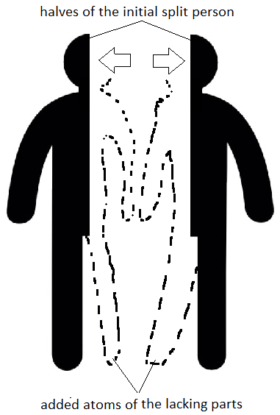
if you ask a question: “where will I be in this case”, theists, who imagine the soul as a thing, will face complications. they can imagine that:
1. a soul is also split, in which case the question “where will I be” stays unanswered;
2. my full soul stays in one half (which is me), while the other half becomes a zombi, or receives a new soul, in which case the question “what determines which half keeps my soul” stays.

materialistic soul
a materialist, who doesn’t imagine the soul as a thing added to the body, answers it simpler: “you will be the right half🙂.”.
then you’ll get surprised: “why so?! what is there special about the right, that -I-☝️ will be it?🤨”.
and the response will be laughter: “ha-ha-ha, the right part is asking why it is right! the other, left part has also just asked the same question.” you’re absolutely right, there’s nothing special about the right part. and there’s nothing special about you🤷. Buddha was right - consciousness is an illusion (meaning our view of consciousness as an addition to the body).

